- Briefly describe your resume from the perspective of Data analysis.
In my professional experience as a Business Data Analyst I have dealt with data in almost all of my projects where at times I was responsible to do data analysis, gather requirements to design a database structure with the DBA team, data integration, write SQL queries to do QA testing and validation of the application.
JD Power and Associates:
  - For example when I was working as a BA with JD Power and Associates I was extensively involved with data when designing the Power Information Network system which is a unique, nationwide data collection system that aggregates daily new- and used-vehicle transaction information from more than 7,500 automotive retailers nationwide.
  - So by using this system it not only gives opportunity to understand the dynamics of each vehicle purchase but also helps manufactures, supplier and retailers to see what programs are most effective and which combination of vehicle pricing and incentives are optimum for increasing sales, reducing costs and improving profit margins.
  - Data collection points that PIN collects - demographics, vehicle transaction information, finance and insurance data, and sales-related information.
  - Manufacture benefits’ from the PIN system - to determine how consumers respond to varying levels of new-vehicle pricing and to understand how price changes affect demand.
  - Predict cannibalization - PIN data is used to gain insight into patterns of inter-brand competition and understand how sales increases for one model will affect the sales of a similar model within the same brand.
Kohl’s Corporation, Inc
- Another example, when I was working for Kohl’s as a Business Marketing analyst I was involved with data to understand the consumer buying behavior and generate weekly, daily and monthly reports using MS Excel to understand the sales target we achieved during a particular month.
- I have also used tools like Business Objects to generate reports for upper management to gauge and understand our core MVC (Most Valued Customers) customers and send them weekly coupons and lowest sales prices on our product line as a Marketing initiative. And also create an opportunity for the demographics among empty nesters that are within the age group of 45 to 54 and single women ages 25 to 34.
- In addition, I have also used MS Excel to generate reports to understand how a consumer navigates to the ecommerce site Kohl.com and was able to improvise the ecommerce site with the problems it was facing in its web sales like search functionality, the checkout process and the overall look and feel.
- What is Data Modeling?
Data modeling is a method used to define and analyze data requirements needed to support the business processes of an organization.

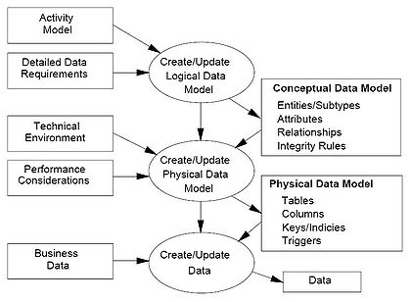

The data modeling process: A conceptual data model is developed based on the data requirements for the application that is being developed, perhaps in the context of an activity model. The data model will normally consist of entity types, attributes, relationships, integrity rules, and the definitions of those objects. This is then used as the start point for interface or database design.

- Scenario: If there are two different databases how would you transfer data between them successfully?
Using a SQL Loader you can transfer data from an external file to an Oracle Database.
- What language did you use in Oracle?
I have used PL/SQL language in addition I have also incorporated SQL DDL and DML statements inside the PL/SQL Block
- When you are given a data source, how will you handle Data normalization?
- When you are given a data source, what are the characteristics you will look for in the data?
- What are the different databases or environments that you have worked with?
- Other than ER relationships, how will you define relationships between tables?
- How comfortable are you with SQL; can you create a data base or just run advanced queries?
- Will you be comfortable in an agile environment?
- What percentage of data analysis as well as business analysis you have incorporated in each project?
- What is Data Analysis?
- Will you be able to take a role of a DB Developer?
- What is Data Imaging?
- How have you used MS access? Have you used it other than reporting?
- What tool would you use to define many to many relationships within a database?
- What is Data Mapping? Have you done data mapping? How did you do it?
- How good you are at SQL, tell me about Create and Alter table commands?
- Tell me about Data migration tools you have used? Have you dealt with Data Migration in any of your projects?
- What is your experience with Excel and pivot tables?
- Scenario: From the tables below create an SQL Query to identify only the dissatisfied customers
Customer ID Survey Response (D= Dissatisfied; S=Satisfied)
D
S
S
D
D
S
S
D
    - Nth Customer ID
- Scenario: Give the SQL query to pull only (3,4)
Table 1 Table 2
1 3
2 4
3
4
5

- What is your experience with Data integration? What are the tools you have used for this purpose?
  - Data integration involves combining data residing in different sources and providing users with a unified view of these data. So, this project was a perfect candidate for Data Integration since the customer data (customers of the bank) resided in multiple SORs.
  - I have used Business Objects Data Integrator tool to integrate the data from the credit bureaus like EquiFax and Experian into our staging database so that the web based application Customer Tracker can present a unified view of the data from our own SORs as well as from these external sources. This will help the bankers and other users of the application understand the customer behavior/ credit reports/credit scores for a particular customer so that specific marketing efforts can be made towards these individuals.
  - Credit Report Contains following information ;
- Consumer / Personal Information - your name, address and employer.
- Credit Information - outstanding mortgages, loans, and lines of credit carrying balances at banks.
- Account History - information on your payment patterns and collections activity as reported by agency partners.
- Public Records Information - information available to the general public due to the involvement of a court proceeding. This can include bankruptcy filings, claims and monetary judgments against you.
- Inquiry Information - companies that have recently requested a copy of your credit report.
- Personal Statements - this is where you can provide a statement concerning the information contained in your credit report.

General Information:
What is SQL*Loader and what is it used for?
SQL*Loader is a bulk loader utility used for moving data from external files into the Oracle database.
How does one load MS-Excel data into Oracle?
Open the MS-Excel spreadsheet and save it as a CSV (Comma Separated Values) file. This file can now be copied to the Oracle machine and loaded using the SQL*Loader utility.
Is there a SQL*Unloader to download data to a flat file?
Oracle does not supply any data unload utilities. Here are some workarounds:
- Using SQL*Plus
You can use SQL*Plus to select and format your data and then spool it to a file. For example you can spool out a CSV (comma separated values) file that can be imported into MS-Excel:
SQL*Plus
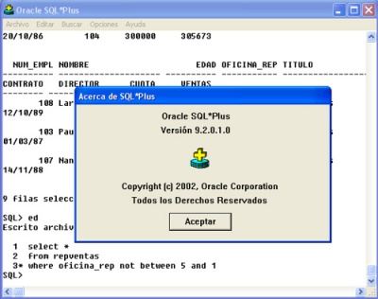
SQL*Plus is a command line interface to the Oracle Database. From SQL*Plus, one can issue SQL, PL/SQL and special SQL*Plus commands.
- Using PL/SQL
PL/SQL's UTL_FILE package can also be used to unload data.
- You can also use some third party software’s like TOAD from Quest Software

TOAD
TOAD (Tool for Oracle Application Developers and DBAs) is a database administration and SQL development software application from Quest Software. TOAD is a very popular tool with a large user base. It includes a SQL Editor, Schema Browser, Procedure Editor, SQL Modeler, etc.
TOAD is also available for other database systems, including SQL Server, DB2 and MySQL.

What is SQL Developer?
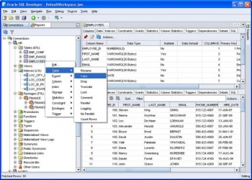
Oracle SQL Developer GUI
SQL Developer is free graphical IDE (Integrated Development Environment) for developing SQL and PL/SQL code. The product is aimed at Oracle DBA's and developers - and should generally not be given to end users. It also provides basic connectivity to MySQL, SQL Server and Access databases, mostly for the purposes of data migrations.
What are the advantages of ETL tools versus traditional programming?
http://www.information-management.com/news/1036675-1.html

References for some more additional Data related things
http://www.robdavispe.com/free2/software-qa-testing-test-tester-2213.html
http://en.wikipedia.org/wiki/Data_integration
http://www.learnbi.com/bi_data.htm ------- this is amazing
http://it.toolbox.com/wiki/index.php/Data_Warehouse_Concepts#Staging_Area ------- this is amazing
http://www.bipminstitute.com/data-warehouse/etl-transformation-design.php
http://www.stylusstudio.com/tutorials/data_integration_tutorials.html
http://articles.techrepublic.com.com/5100-10878_11-5029912.html?tag=rbxccnbtr1
http://www.altova.com/videos.asp?type=0&video=mapforce

